**Setting Up Hardware 2 Factor Authentication Using YubiKey.**



**Introduction**

In the world of technology today one of the main ways hackers gain access is by phishing for your information. Two Factor Authentication is used by most websites and applications to mitigate this threat by using phone or email to authenticate you when logging in with your passwords. If the individual in question is reusing passwords this may also be compromised. To add an extra layer of protection one can use a form of hardware authentication such as a YubiKey. When the haptic sensor on the YubiKey is touched, while the device is inserted / tapped, This device generates a hex key stored on it authenticating “you” as the user.

**Equipment / Prerequisites**

* Personal computer with Linux, Mac OSX, or Windows
* YubiKey 5 NFC
* Iphone or Android
* Google Account
* KeePass Password Database

***\*\*Do Not Associate the Lab Key with your personal accounts or you will be locked out\*\****

**Instructional**

**Part 1: Setting Up 2 Factor Authentication on the computer’s operating system.**

1. **For Microsoft Windows 10, the following instructions are:**
   1. Download Yubico Login For Windows from this URL <https://downloads.yubico.com/products/Yubico-Login-for-Windows-2.0.3-win64.msi>

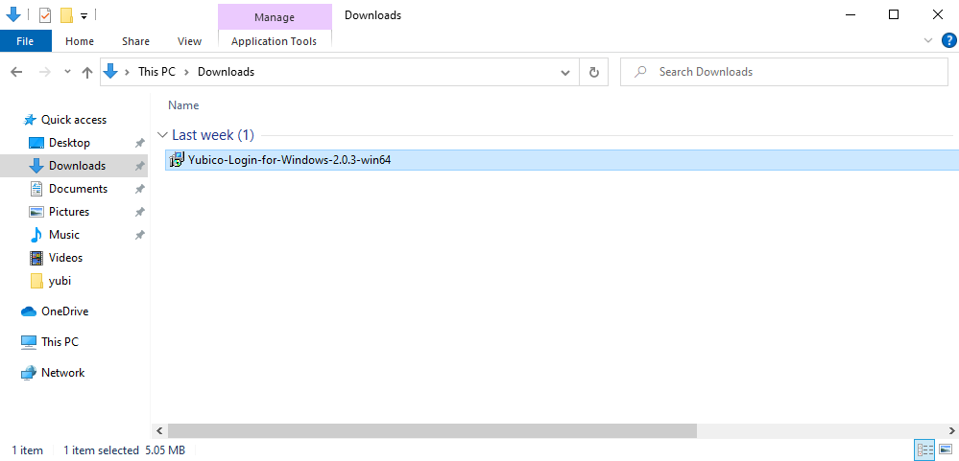

* 1. Navigate to the downloaded file.

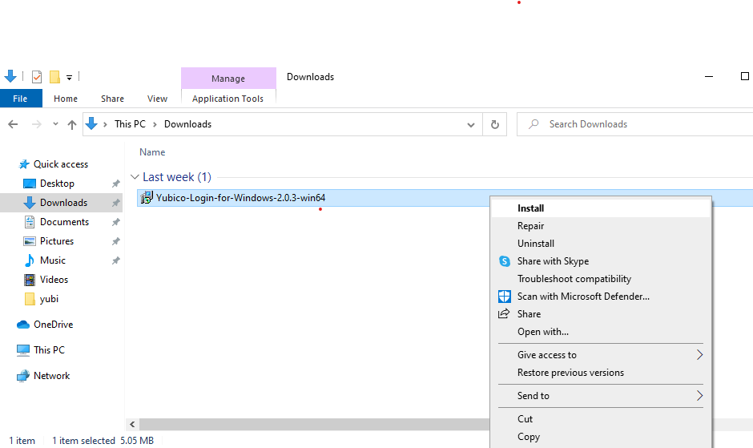

* 1. Run the install of the download by double left clicking on the **msi file** or right click and select **install**.

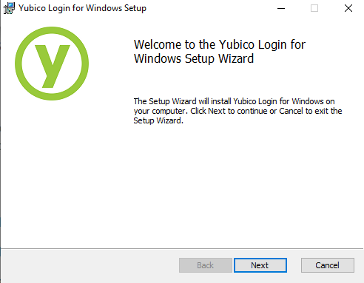

* 1. Click **Next**.

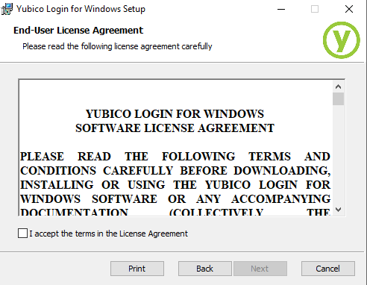

* 1. Use the scroll bar and read the EULA completely to the end.

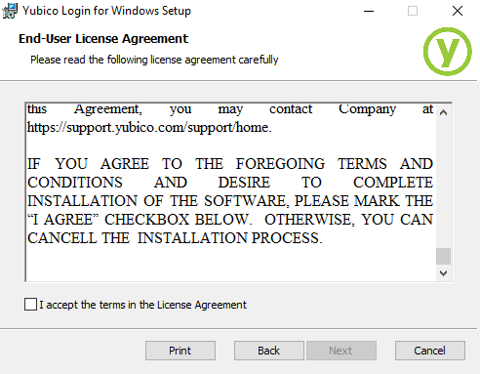

* 1. Click the **checkbox** “I accept” and **Agree** to the terms in the License Agreement.

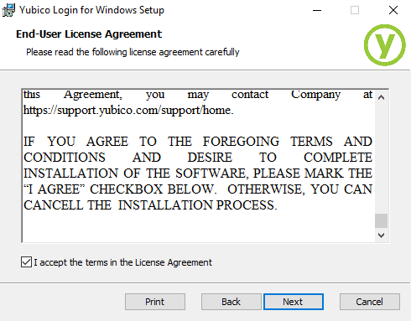

* 1. Click **Next**.

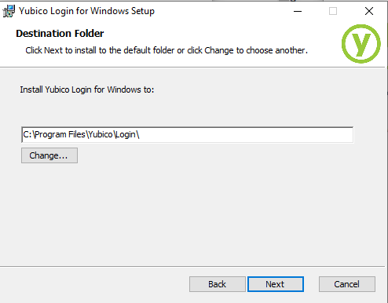

* 1. Click **Next**.

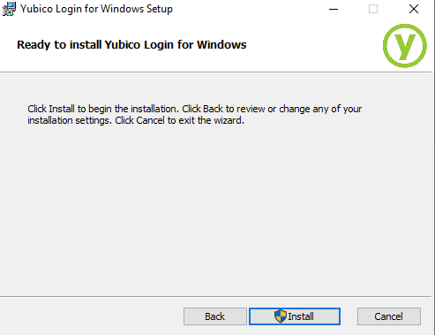

* 1. Click **Install**.

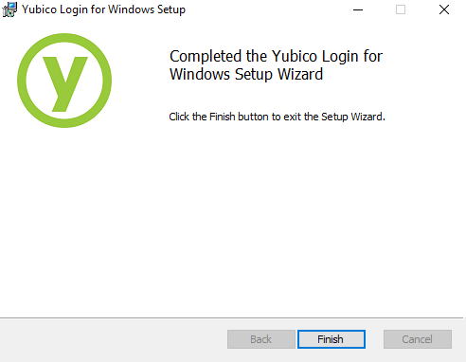

* 1. Click **Finish**.

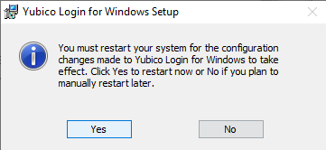

* 1. Click on **Yes** for **Restart** and **Reboot**. **Insert** the Yubikey into the computer.
  2. After reboot login back into the computer with your **account name** and **password**

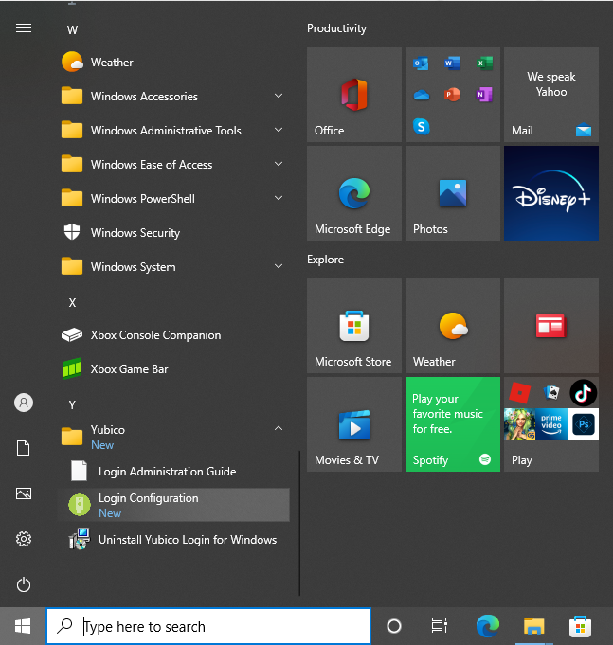

* 1. **Open** the start menu.



* 1. Open the Yubico Login for Windows application.

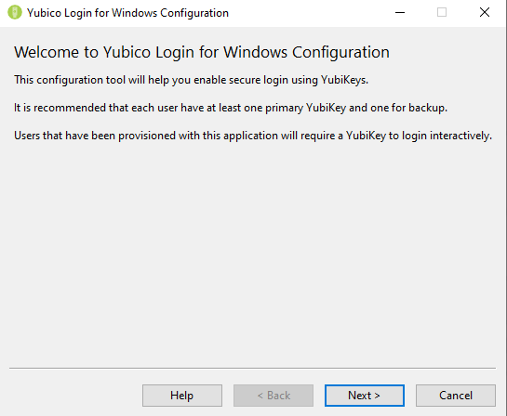

* 1. Click **Next** on the welcome screen.

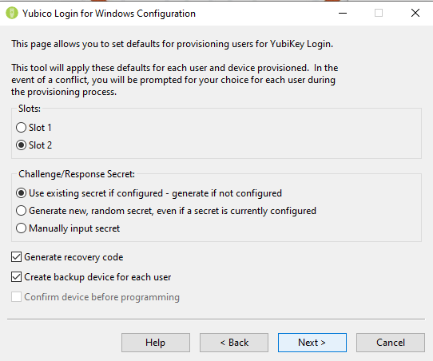

* 1. **Select** Slot 2 and Click **Next**.

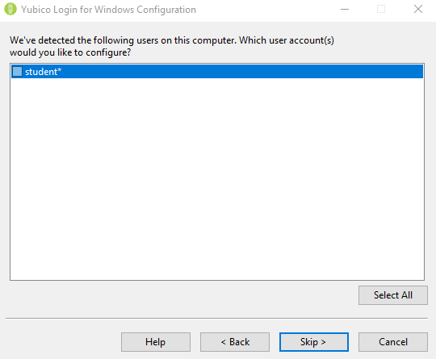

* 1. **Select** a user, by putting a check into the checkbox to the left of the user name.

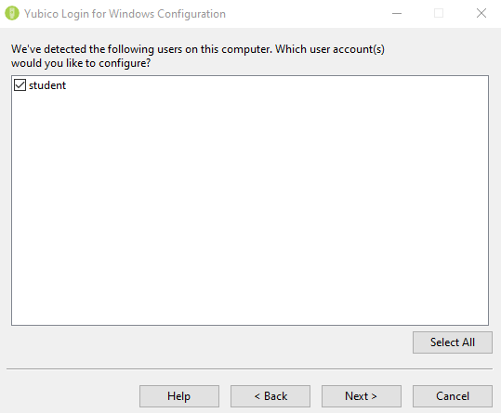

* 1. Click **Next.**

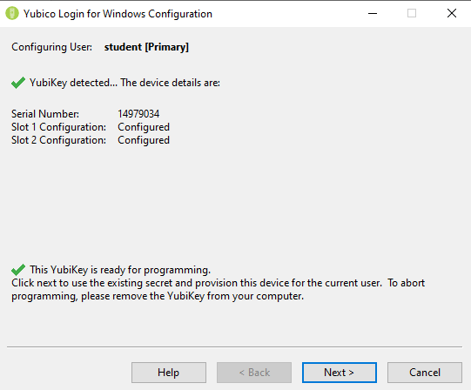

* 1. Click **Next.**

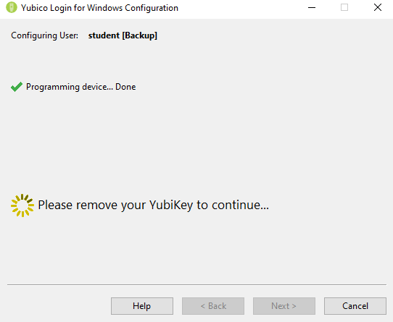

* 1. **Remove** the Yubikey.

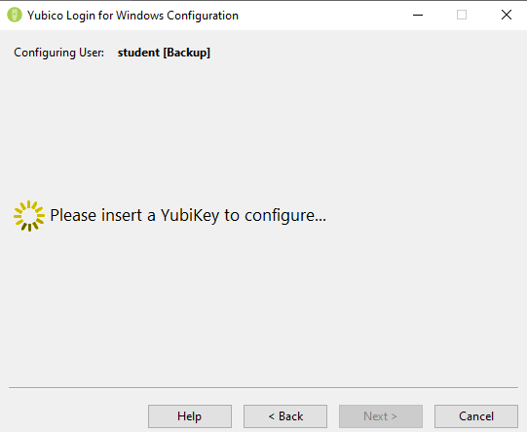

* 1. **Reinsert** the Yubikey.

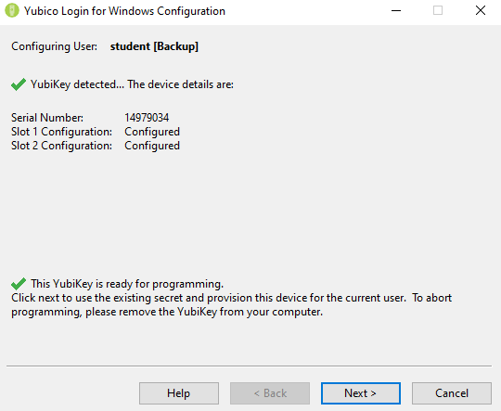

* 1. Click **Next.**

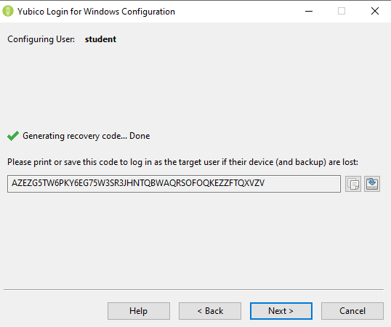

* 1. **Copy** and **Save** the backup code to a safe off-site location **Text Document**.

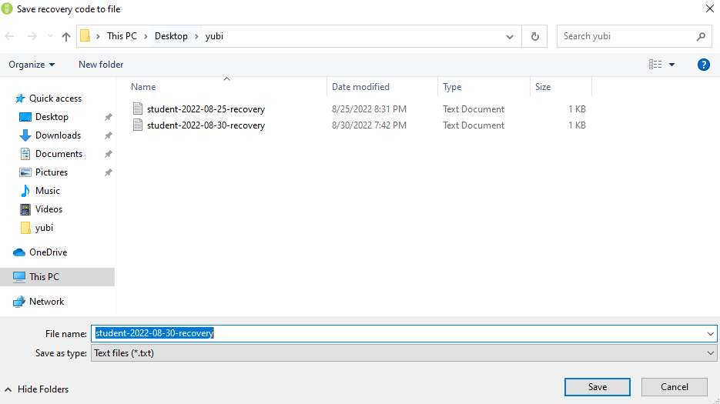

* 1. Navigate to a save location, then click **Save**.



* 1. Click **Next**.
  2. Optionally: insert a secondary Yubikey if you have one and Click **Next**.

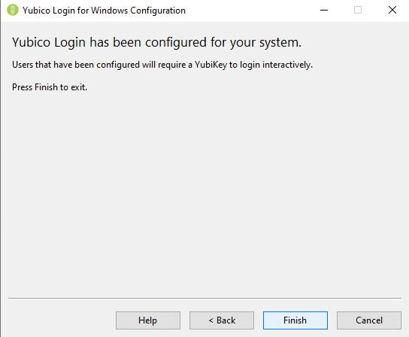

* 1. Click Finish.

***\*\*Congratulations you have now installed Yubikey for 2FA on your Microsoft Windows computer\*\****

**Removal of the YubiKey 2 Factor Authentication on the computer’s operating system.**

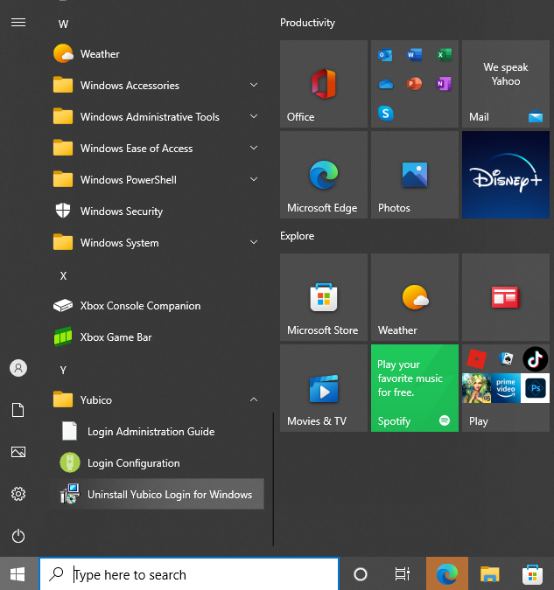

1. **Click on the start menu, then click on uninstall Yubico login for Windows.**

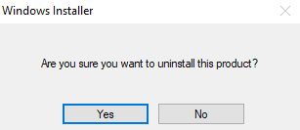

1. **Click Yes.**

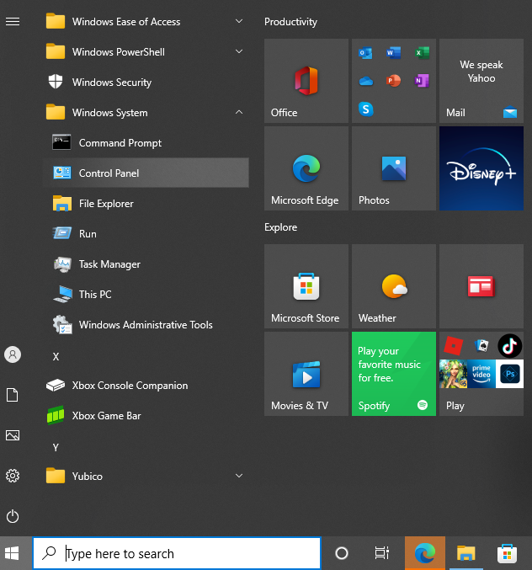

1. **Optionally, click on the start menu, then click on control panel.**

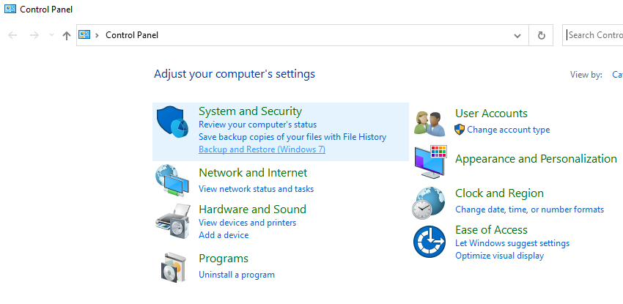

1. **Click on Uninstall a program.**

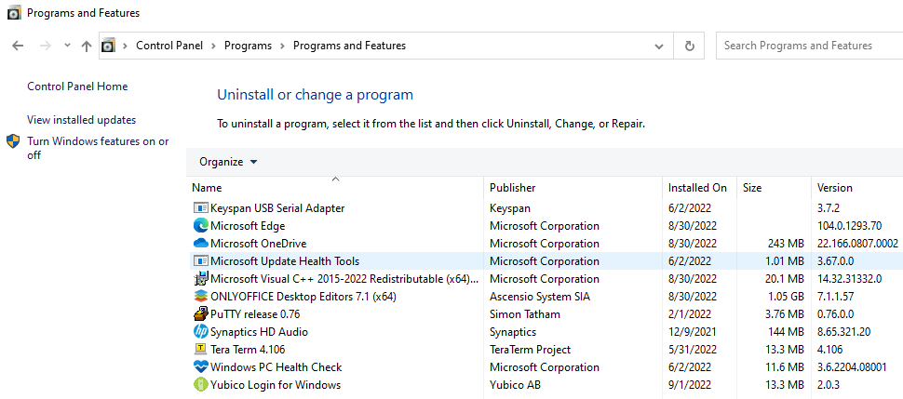

1. **Select Yubico, then Select Uninstall.**
2. **For Debian based distribution of Linux, the following instructions are:**
   1. Update the repositories with the command **sudo apt update && sudo apt dist-upgrade**.



* 1. Install **libpam-u2f** with the command **sudo apt install**.



* 1. Make a directory named **Yubico** in the **.config** parent directory with the **mkdir** command with the command line argument **-p**.



* 1. Plug in the **Yubikey** and enter the command **pamu2fcfg >** to register the key. Use the symbol **>** to redirect the results to the directory you created.



* 1. When the key flashes, touch the “Y” in the center of it.
  2. ***To Secure Sudo permission*** open the file **/etc/pam.d/sudo** with **root permission** using **nano**.



* 1. Add the text below after **@include common-auth**.

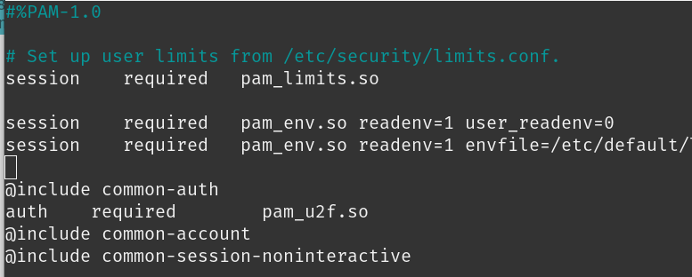

* 1. Press **Ctrl + O**, **Enter**, and **Ctrl + X** to save and exit.
  2. ***To Secure login*** plug in the yubikey thenopen the file **/etc/pam.d/gdm-password** with **root permission** using **nano**.



* 1. When the key flashes, touch the “**Y**” in the center of it.
  2. Add the text below after **@include common-auth**.

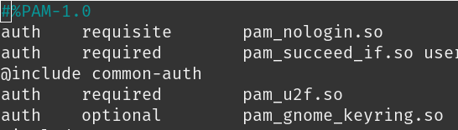

* 1. Press **Ctrl + O**, **Enter**, and **Ctrl + X** to save and exit.
  2. ***To Secure TTY Access*** open the file **/etc/pam.d/login** with **root permission** using **nano.**

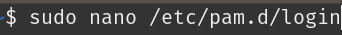

* 1. Press **Ctrl + W** to search and enter **@include common-auth**. Press **Enter**.

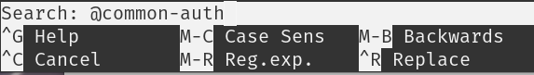

* 1. Add the text below after **@include common-auth**.

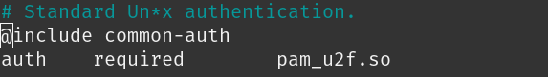

1. **OSX**
   1. Download **Yubikey Manager** from this link: <https://developers.yubico.com/yubikey-manager-qt/Releases/yubikey-manager-qt-latest-mac.pkg>.
   2. Follow this **Instruction** to set it up as a smart card: <https://support.yubico.com/hc/en-us/articles/360016649059-Using-Your-YubiKey-as-a-Smart-Card-in-macOS>.

***\*\*Now you can use your Yubikey for 2FA when logging into your computer\*\****

**Part 2: Setting Up 2 Factor Authentication on your Google Account.**

***\*\*Before setting up 2FA be sure to have a recovery method tied to your account\*\****

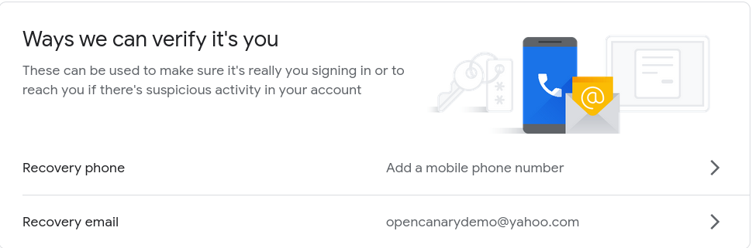

1. Nagivate to [www.google.com](http://www.google.com)

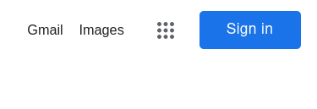

1. Select **Sign In** on the top right.

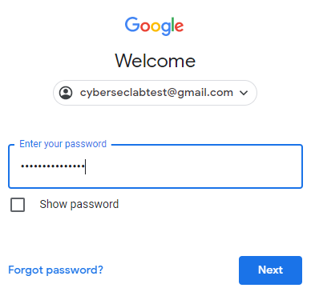

1. Select your **Account** and enter your **Password**.
2. Click **Next**.

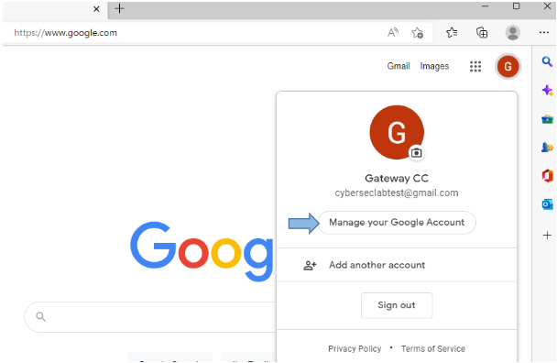

1. Select **Manage Account** from the drop down menu on the top right side.

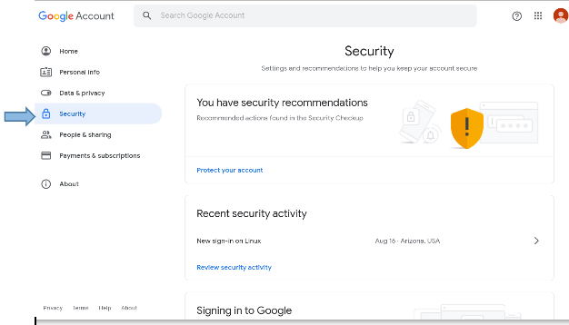

1. Select **Security** from the left Side Bar.

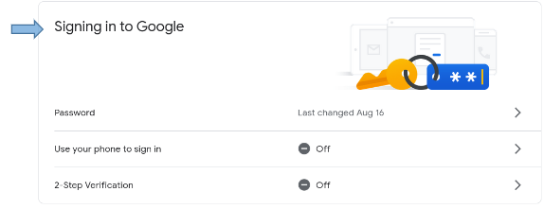

1. Scroll down to **Signing in to Google section.**

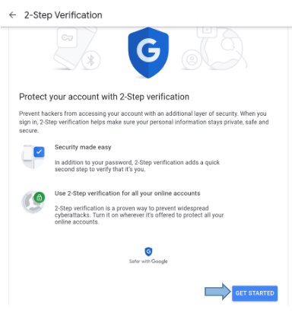

1. Click the arrow to the right of **2-Step Verification**. Click **Get Started**.



1. Enter your **Password** and click **Next**.

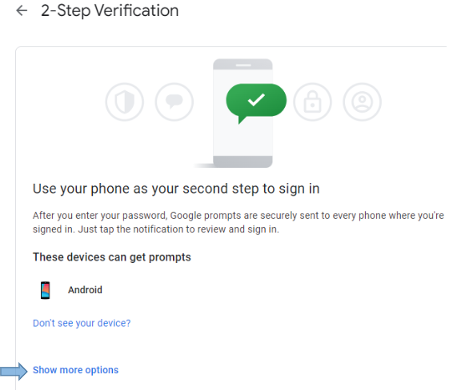

1. Scroll to the bottom and click **Show More Options**.

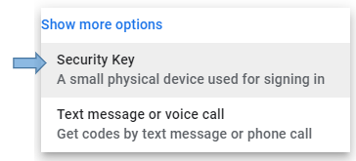

1. Select **Security Key** and click **Next**.

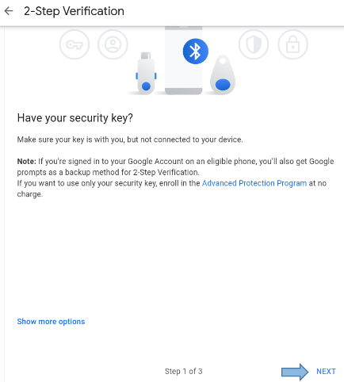

1. Click **Next**
2. Insert the Yubikey into the computer. Tap the “**Y**” on the YubiKey. Give the key a **Name** of your choosing and click **Done**.

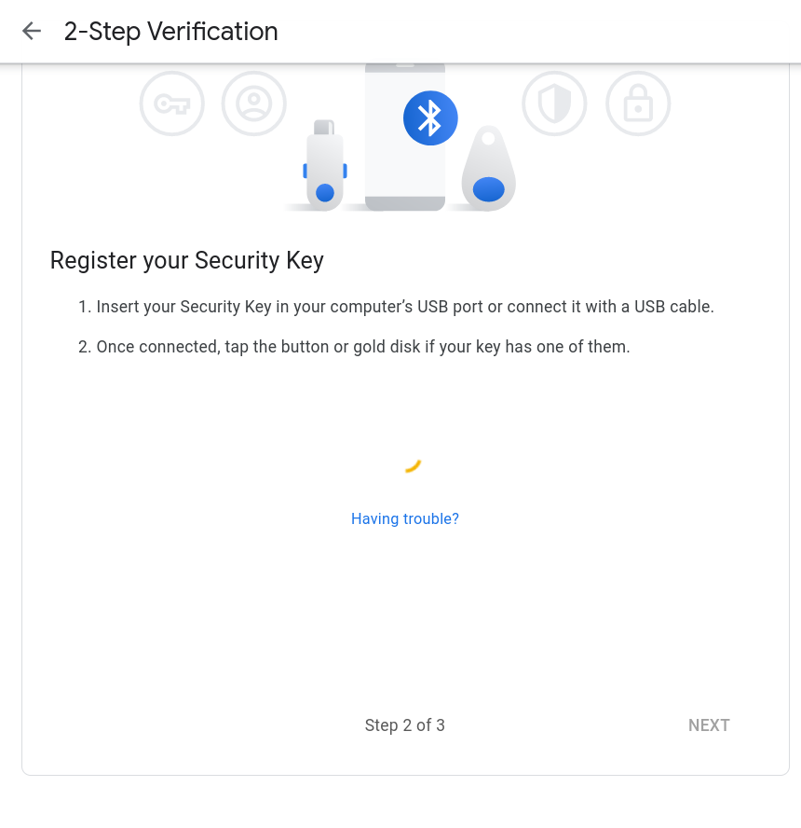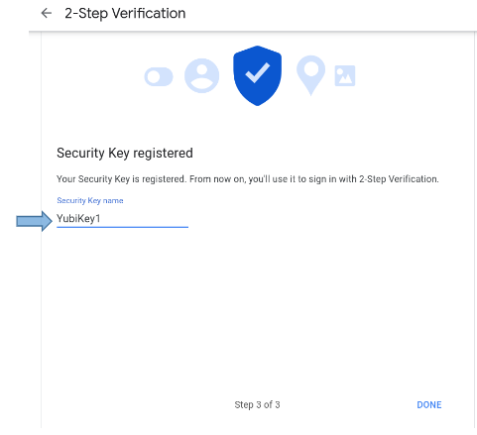

1. Enter a name to **identify** the security key.

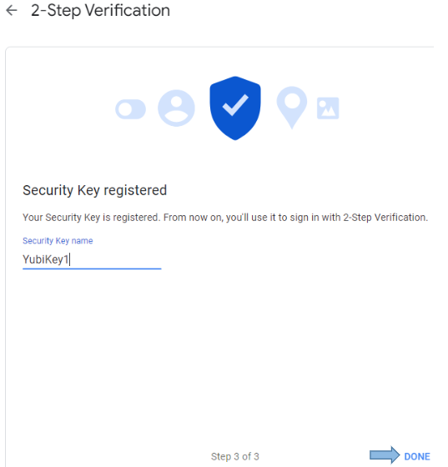

1. Click on Done.

***\*\*Congratulations you have now associated a Yubikey for 2FA on your Google account\*\****

**For removal of the YubiKey 2 Factor Authentication on the your Google account:**

**To remove this specific YubiKey:**

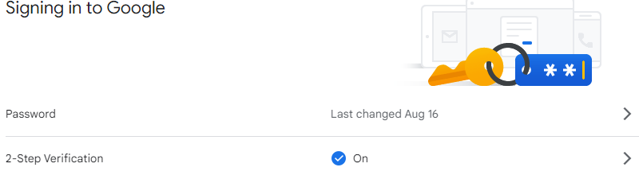

A)In the security section, under the Signing in to Google 2-step verification subsection click on the arrow.



B) Enter your **Password** and click **Next**.

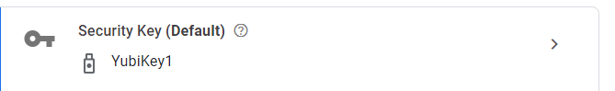

C) Click on the arrow to the left.

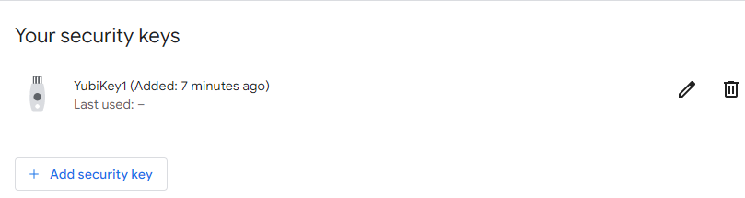

D) Click on the garage bin on the right.

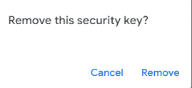

E) Click on remove.

***\*\*Congratulations you have now disassociated a specific Yubikey for 2FA on your Google account\*\****

***To turn off all 2 factor authentication by:***

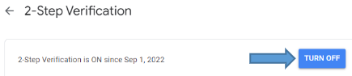

1. In the 2-step verification section, click on Turn off

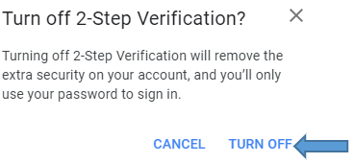

1. Click turn off

***\*\*Congratulations you have now disassociated all 2FA on your Google account\*\****

**Part 3: Using A YubiKey To Store A Static, High Entropy, Password for KeePass.**

**\*\***

1. [**Download** and **Install** your OS’s version of YubiKey Manager from this URL: https://www.yubico.com/support/download/yubikey-manager/](https://www.yubico.com/support/download/yubikey-manager/).



1. At the top left select the Applications drop down menu & Select OTP (One Time Password) from it.

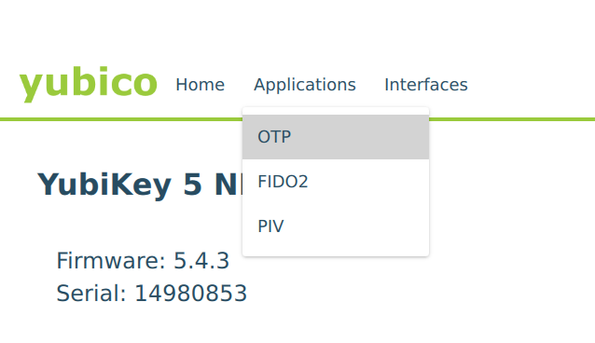

1. Select **Configure** on **Long Touch (Slot 2)**.

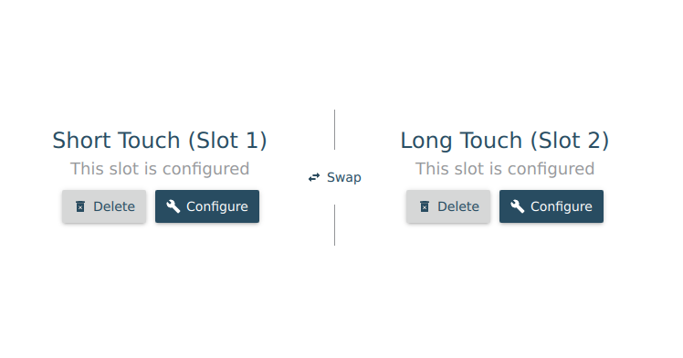

1. Select **Static Password**. Click **Next** at the bottom right.

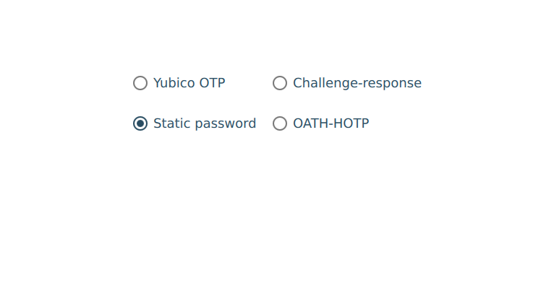

1. Select **Allow any charachter** & **Generate**. Click **Finish** at the bottom right.

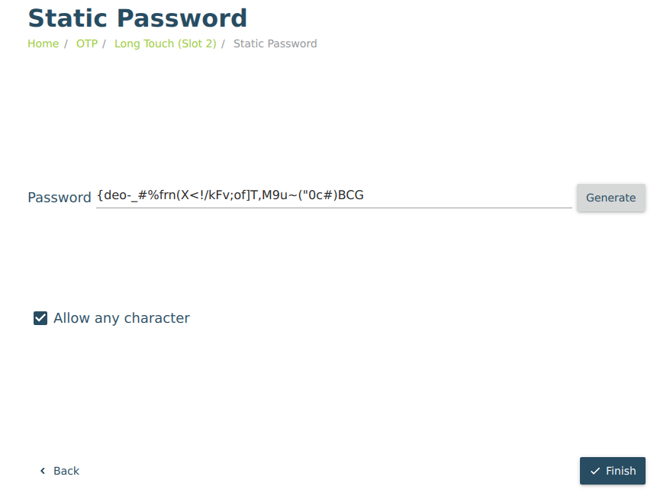

1. ***If you don’t already have a KeePassXC password database***, refer to our writeup available on the lab **Wiki** & add the step below.
2. When prompted in **Part 1** to set the Database Password click the **Enter Password** field, insert the **YubiKey**, and hold the “**Y**” on the **YubiKey** until it begins entering text. Do the same in the **Confirm Password** section.

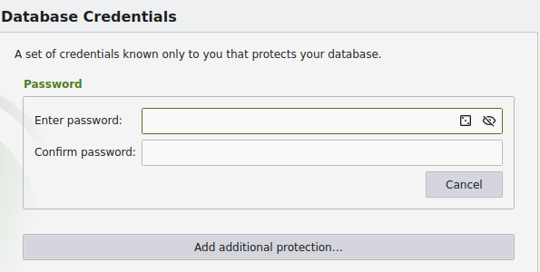

1. ***If you already have a KeePassXC password database***. Open & Login to **KeePassXC**.Click the **Database** drop down menu at the top left of the window. Click **Database Security** from the drop down menu.

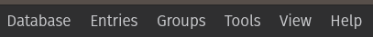

1. Select **Change Password**. Click the **Enter Password** field, insert the **YubiKey**, and hold the “**Y**” on the **YubiKey** until it begins entering text. Do the same in the **Confirm Password** section.

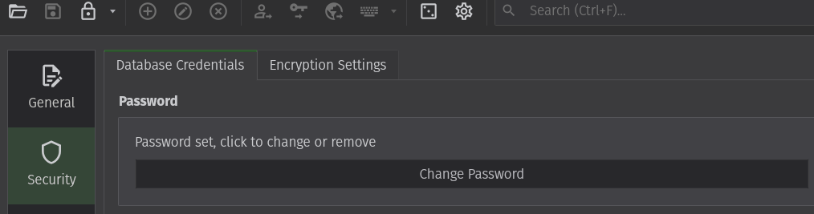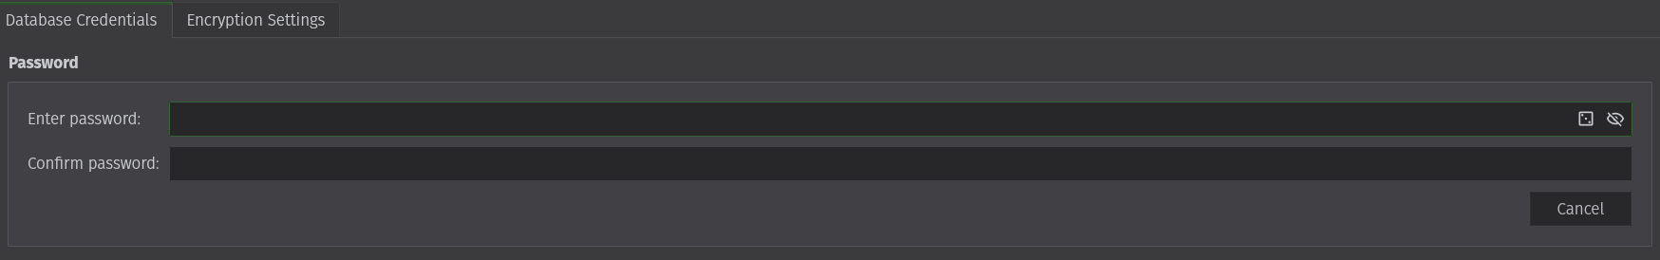

**\*\*Now your YubiKey will Store and Enter the password for your KeePass database.\*\***

**Part 4: Using Your Yubikey’s OTP Function to Log Into Your Microsoft Account.**

1. Open **Microsoft Edge** and navigate to <https://login.live.com>. Sign into your account with your credentials.

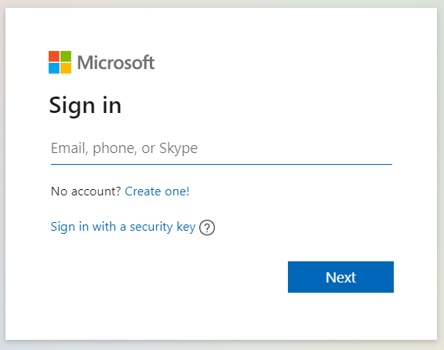

1. Select **Security** on the top left menu. Select **Advanced Security Options**.

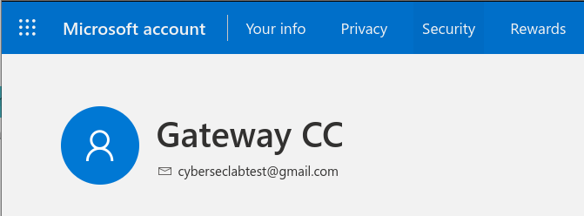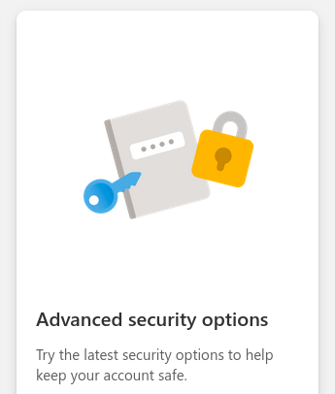

1. In a new tab Login to your email and record the verification code. Return to the other Tab and enter the code.

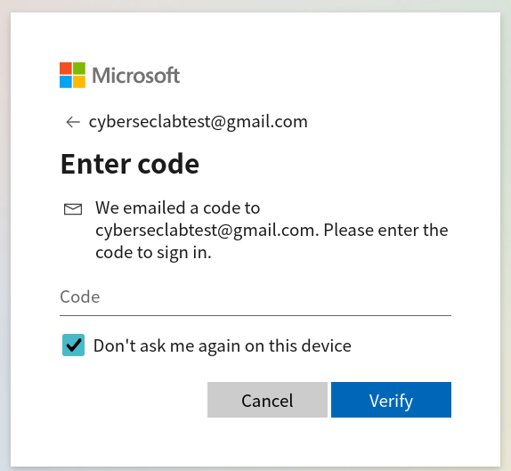

1. Click **Add a new way to sign in or verify**. Select **Show More Options**. Select **Use a Security Key**.

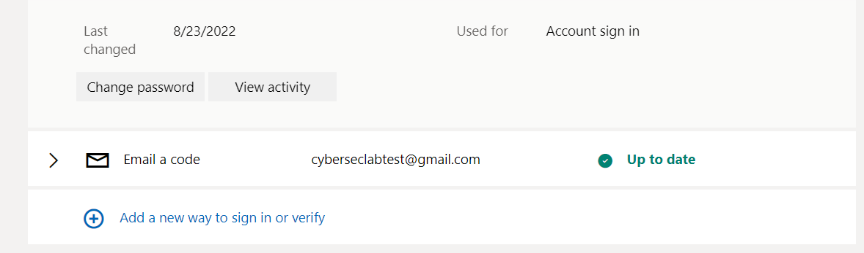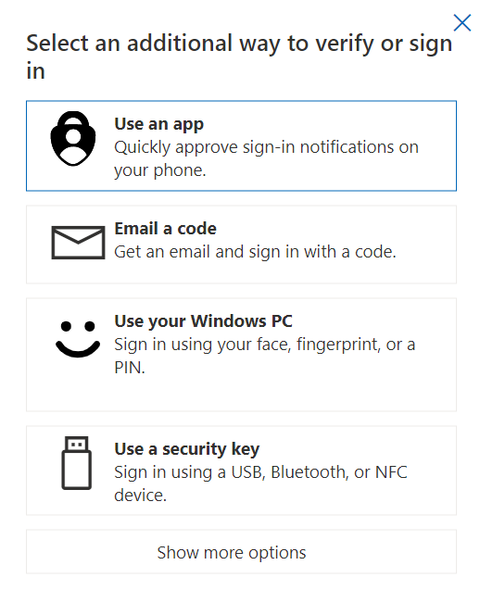

1. Ensure **USB device** is Selected and Click **Next**.

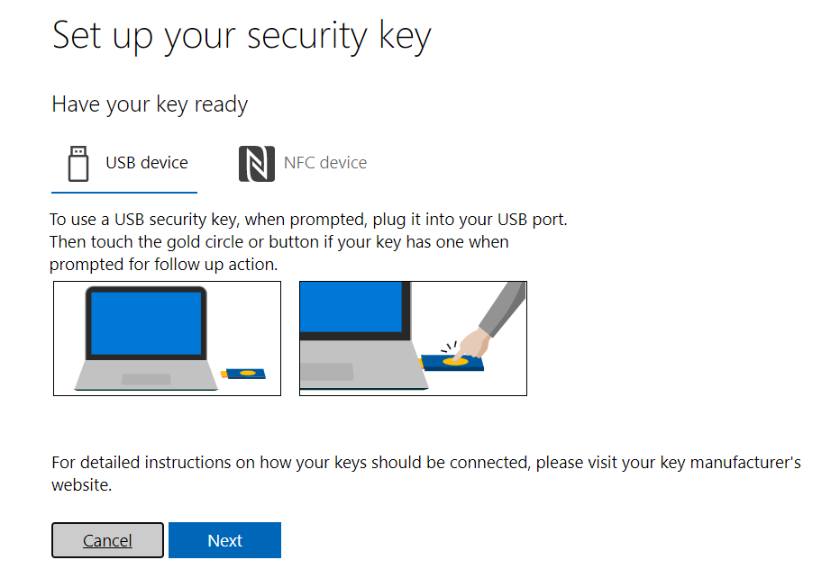

1. Select **External Security Key or Built-in sensor**. **Insert** the YubiKey & Click **Ok** on the next **Two** notifications.

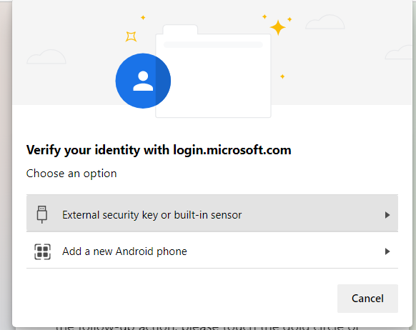

1. **Create** a **PIN** Number to use with the key & click **OK**.

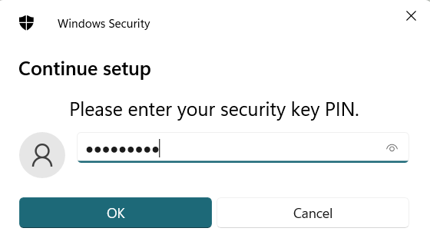

1. **Touch** the YubiKey. **Name** the YubiKey and click **Next**.

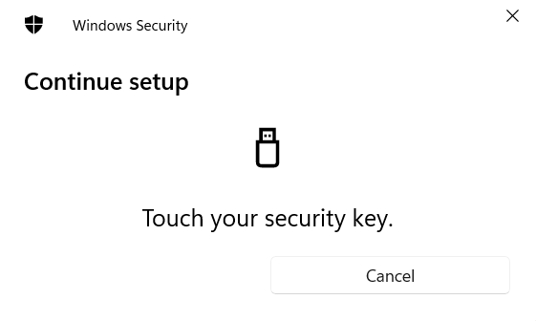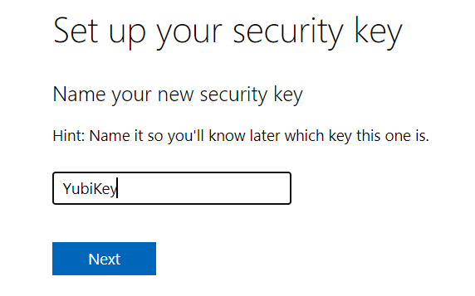

**\*\*Now your YubiKey can be used to login to your Microsoft Account\*\***

**Part 5: Setting Up 2 Factor Authentication on your iOS or Android Device.**

**\*\*The lab key will only work if you have NFC capabilities on your phone. Most accounts will require 2-step verification be already set up in order to add the use of an authenticator app\*\***

1. **iOS**
   1. Download The **Yubico Authenticator App** from the iOS **App Store**.

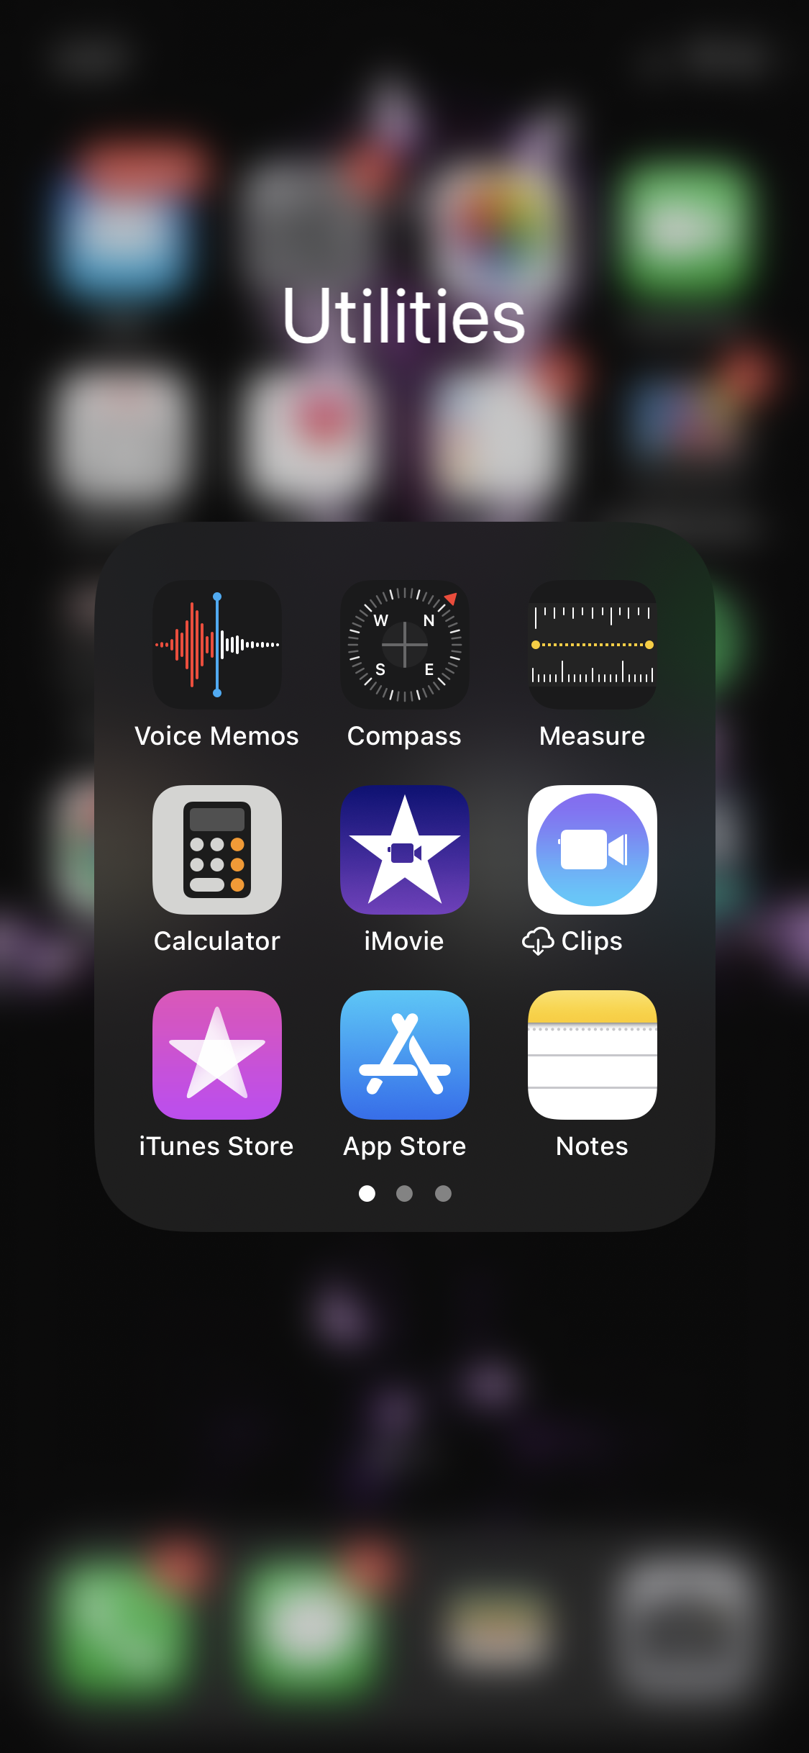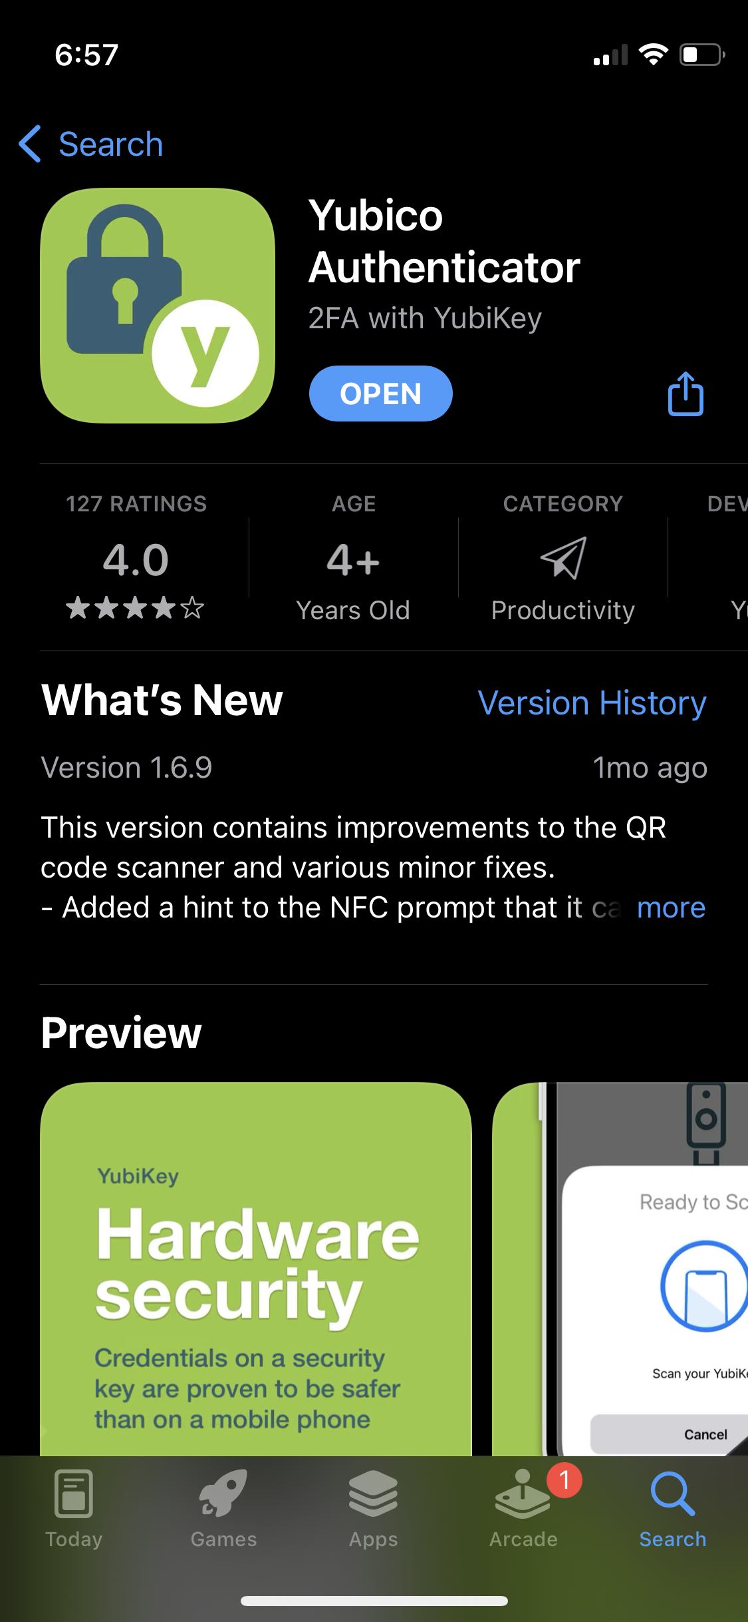

* 1. **Open** the app & **Pull Down** on the screen.

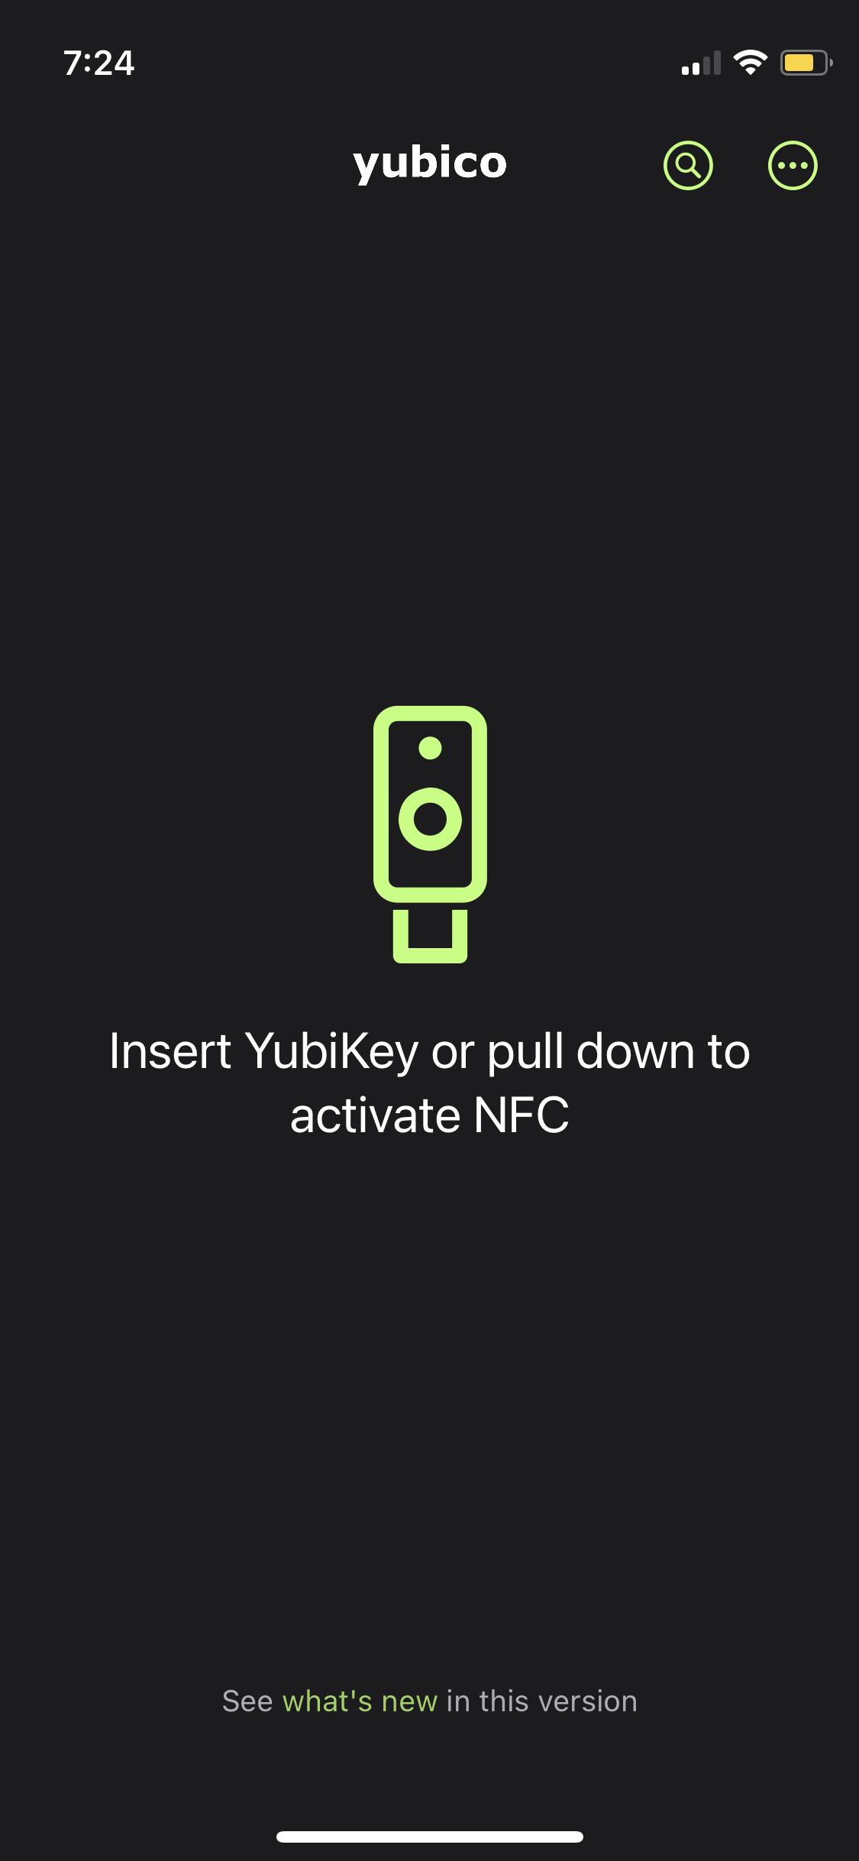

* 1. Tap the YubiKey to the top left side of the Phone.

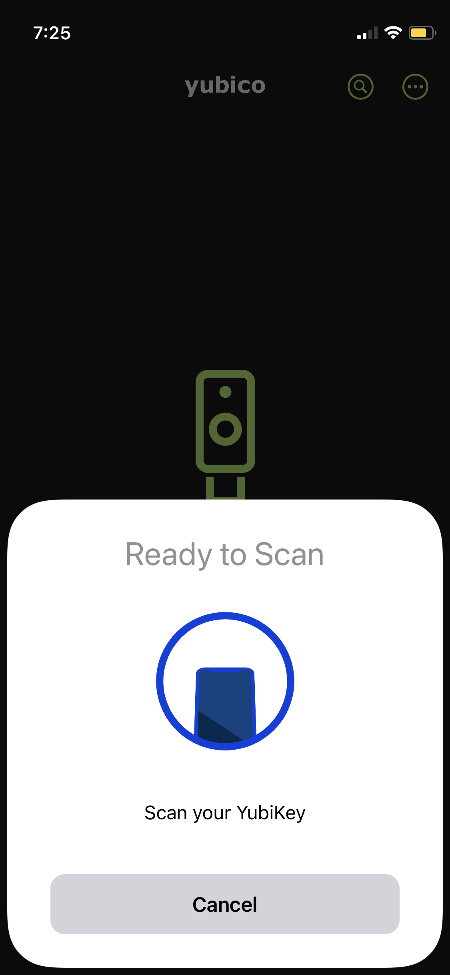

* 1. Using another computer, **Login** to the account you wish to authenticate. Under **Security** — **2 Step Authentication** —Select **Authenticator App**. Select **Setup a different Authenticator App**.

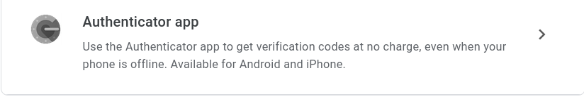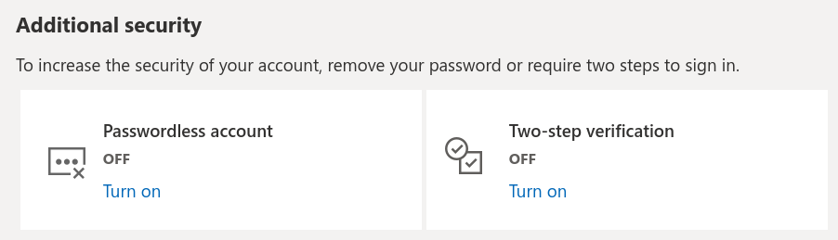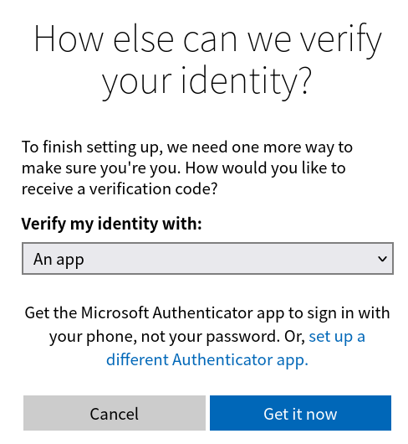

* 1. Return to your phone and Tap the “**Three Dots”** in the **upper right** side of the app. Tap **Add Account**.

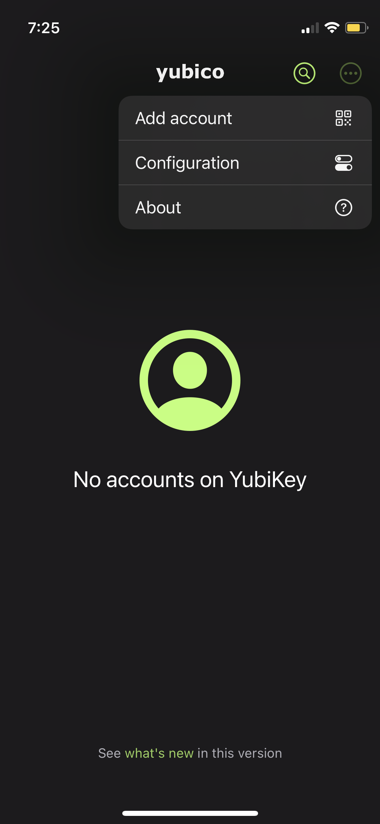

* 1. You will be prompted to **Allow** the app to use the **Camera**. Scan the **QR Code** by placing it between the green square.

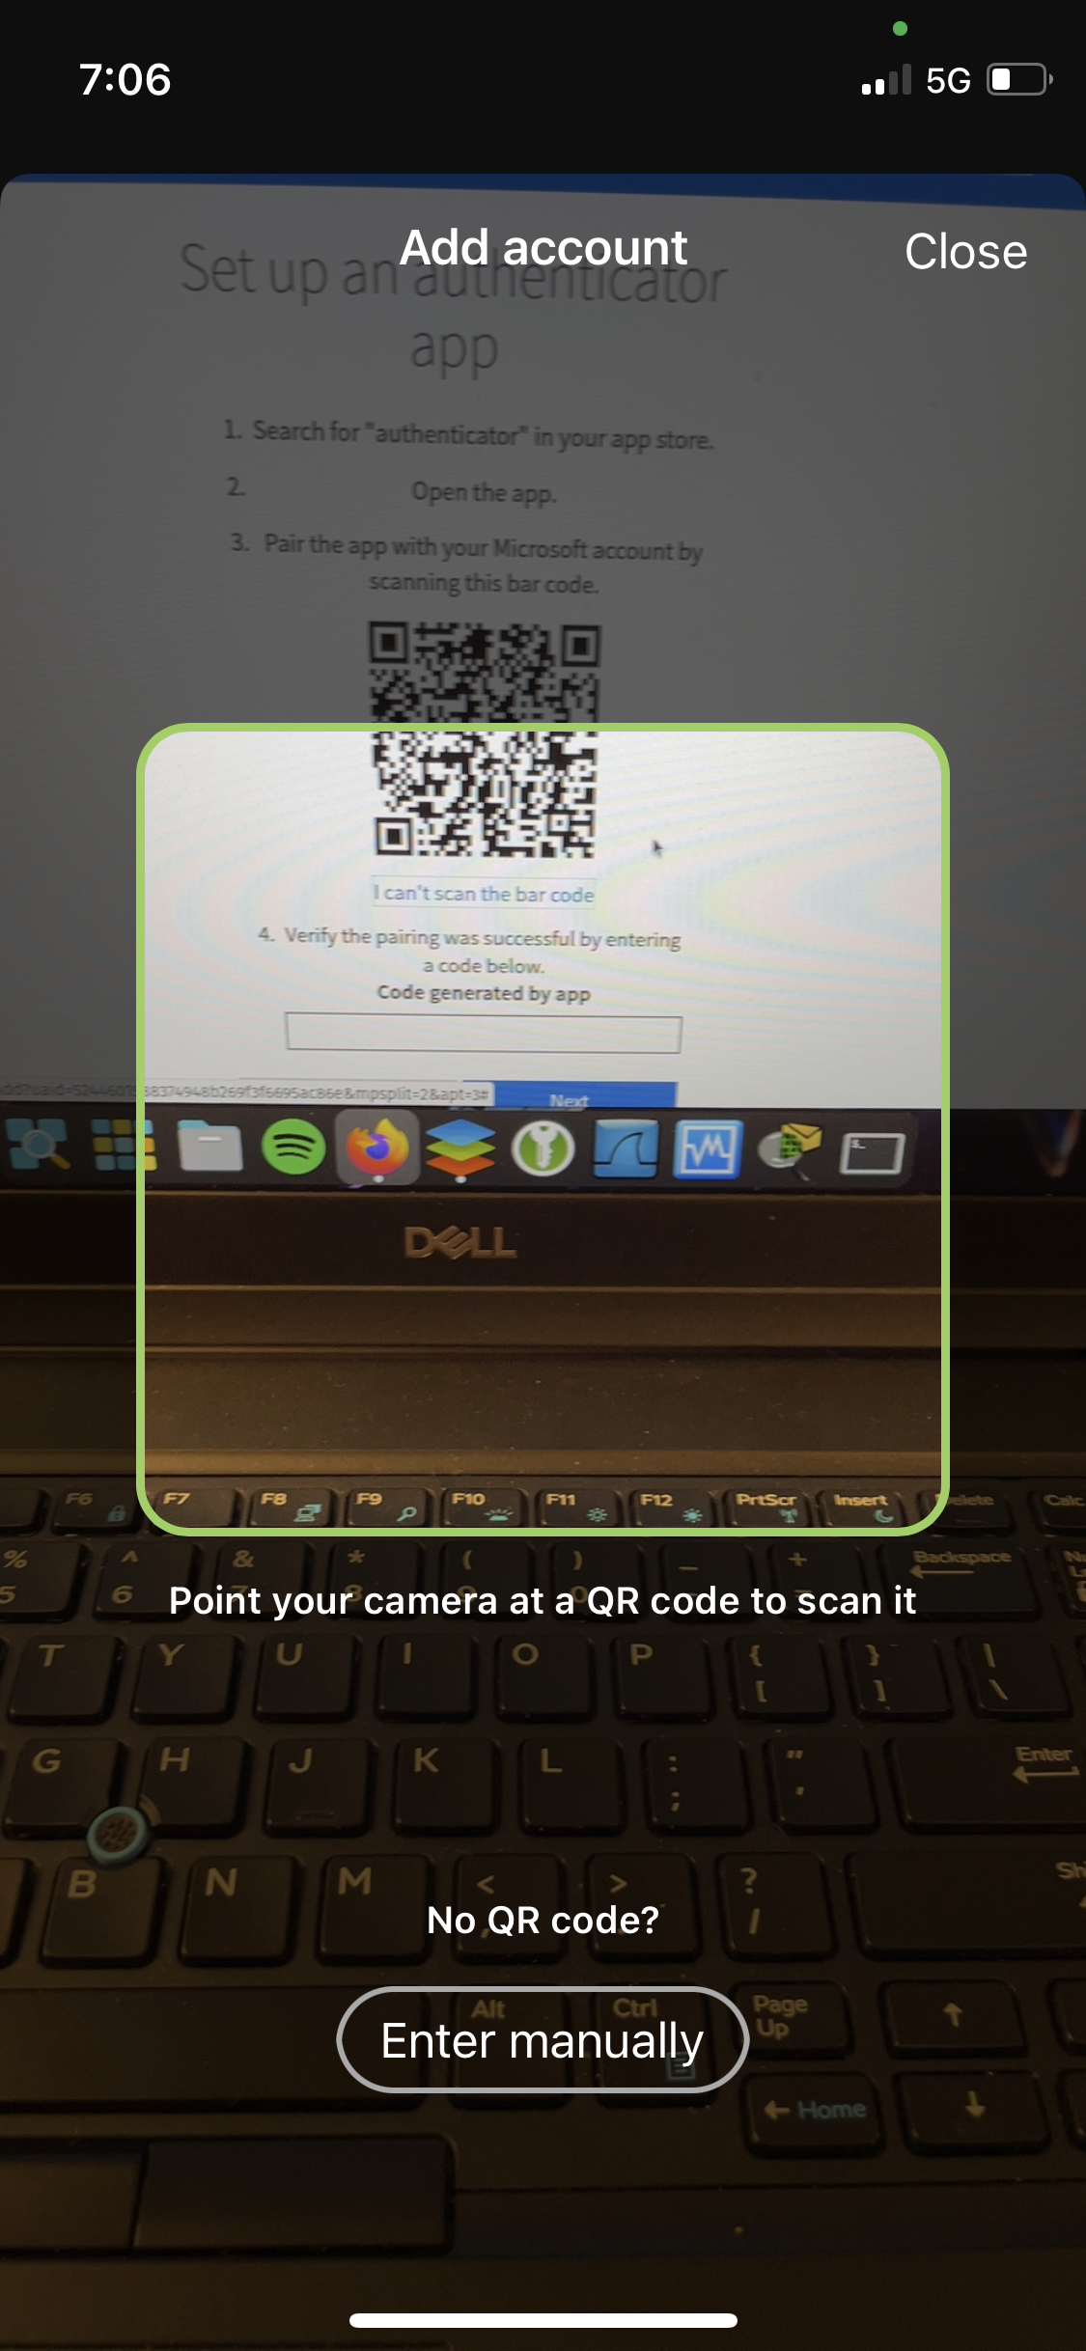

* 1. Tap **Save**. Enter the code generated by the app into the **Code Generated by app** section on the webpage on the **Computer**. Click **Next** or **Verify**.

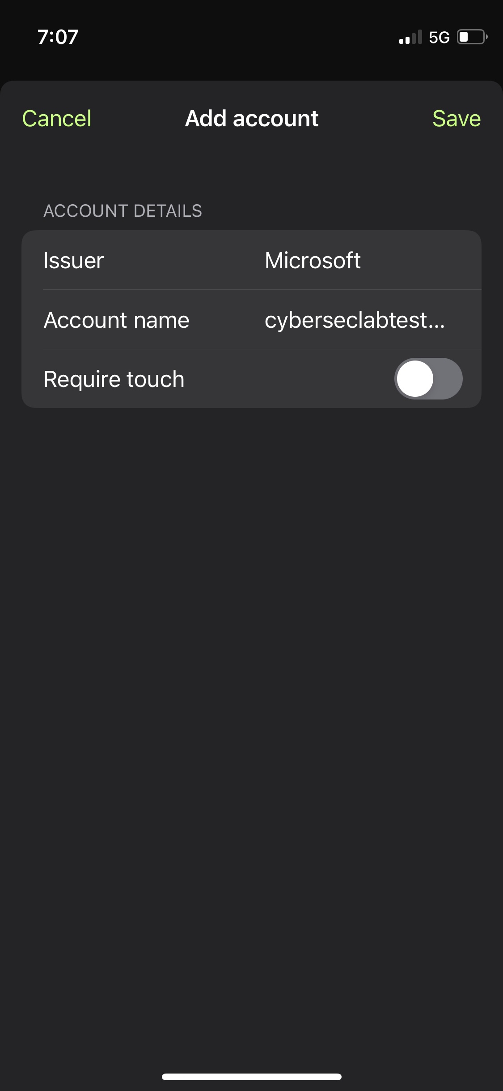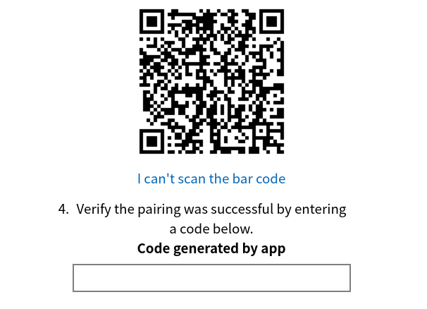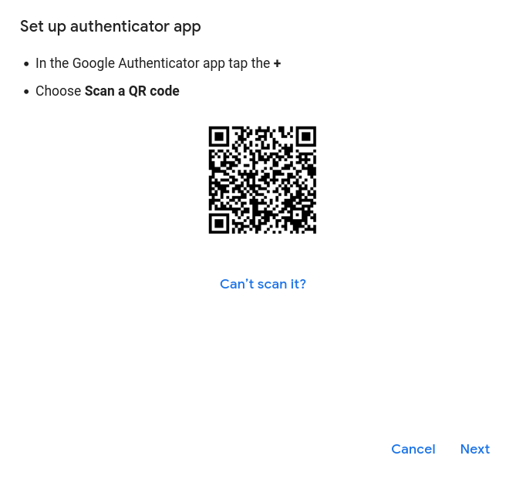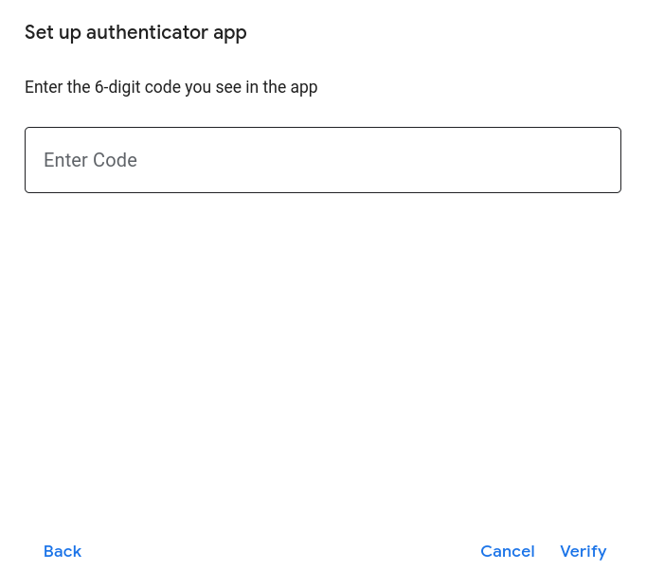

**\*\*Now you can use the NFC on your YubiKey with your phone to provide 2FA\*\***

1. **Android**
   1. Download The **Yubico Authenticator App** from the **Google Play Store**.

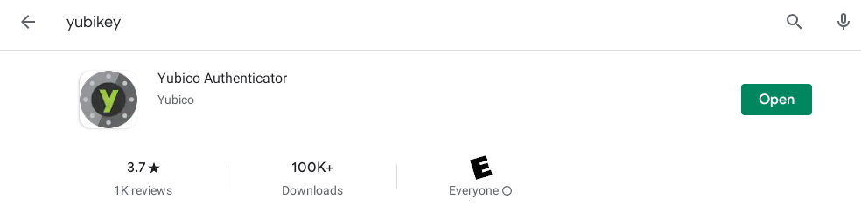

* 1. Using another computer, **Login** to the account you wish to authenticate. Under **Security** — **2 Step Authentication** —Select **Authenticator App**. Select **Setup a different Authenticator App**.



* 1. Return to the phone and **Open** the app. **Tap** the YubiKeyto the top left of the phone. **Select** the **+** symbol at the bottom right of the screen.

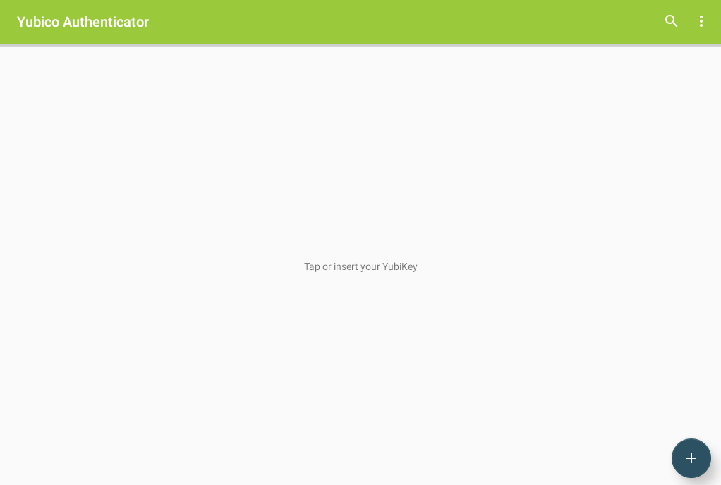

* 1. Select **Scan QR-Code** in the bottom left side of the screen.



* 1. You will be prompted to **Allow** the app to use the **Camera**. Scan the **QR Code** by placing it in the center of the screen.

.

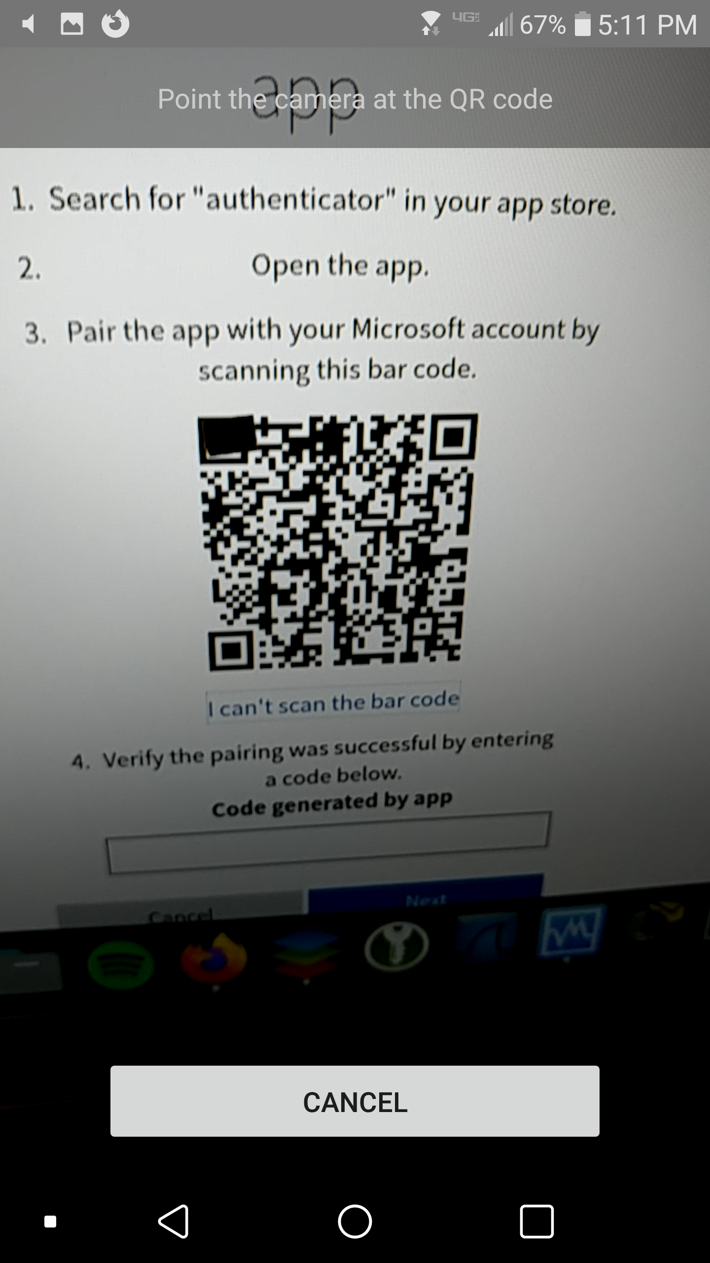

* 1. Tap **Save**. Enter the code generated by the app into the **Code Generated by app** section on the webpage on the **Computer**. Click **Next** or **Verify**.



**\*\*Now you can use the NFC on your YubiKey with your phone to provide 2FA\*\***